**Project proposal for DST & Texas Instruments Inc.**

**India Innovation Challenge Design Contest 2017**

**Anchored by NSRCEL, IIM Bangalore**

**< Smart Water Billing System >**

**< Ramaiah University of Applied Sciences >**

|  |  |  |  |  |
| --- | --- | --- | --- | --- |
| Name | Roll No./ID | UG/PG | Course/Branch | Semester |
| **SHRIDHAR NAGESH HEGDE** | 16ETCS002124 | UG | CSE - Section ‘C’ | 3 |
| **SANTOSH G** | 16ETCS002112 | UG | CSE - Section ‘C’ | 3 |
| **ASHISH KUMAR** | 16ETCS002144 | UG | CSE - Section ‘C’ | 3 |
| **CHINMAYA GAYATHRI** | 16ETCS002401 | UG | CSE - Section ‘C’ | 3 |
| **KAVYA S** | 16ETCS002147 | UG | CSE - Section ‘C’ | 3 |
| **Mentor – Mr. Prakash P** Department of Computer Science and Engineering | | | | |

**Mandatory Supporting Document [to be added along with proposal]**

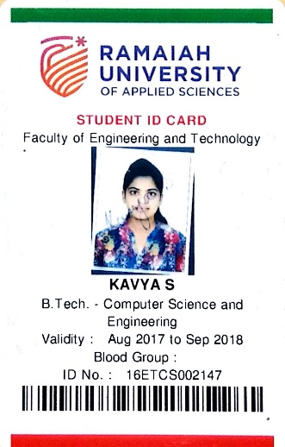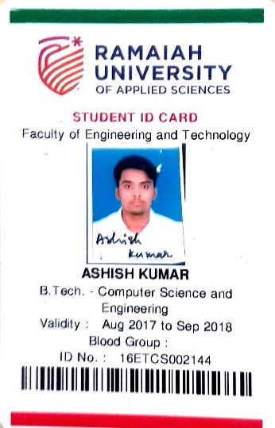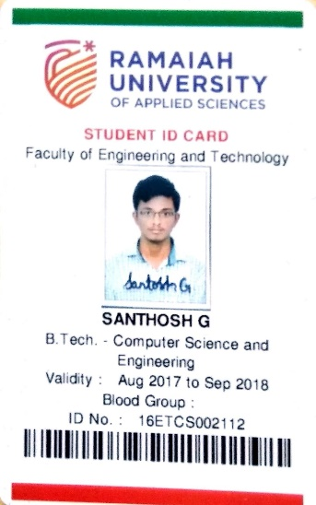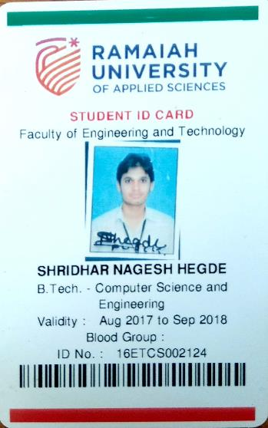

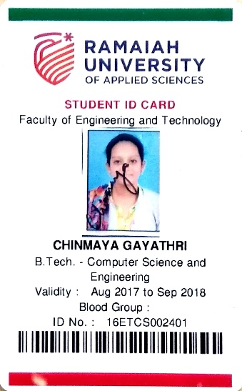

**Project Abstract**

The advancement in the technology has enable to rule out the probability of *“impossible tasks”.* We being the students of Computer Science, felt that we can address the issue of water we see around in the metropolitan cities. That is when the idea of this project was born.

The two main motivations to our project are:

1. **The increasing quantity of non-revenue water (unaccounted water)**
2. **Less revenue generated by the current billing system**
3. **The interstate dispute for water**

Image Source: <https://sensus.com/solutions/non-revenue-water-infographic/>

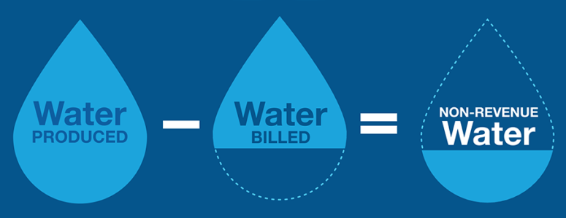 In this project we use the water sensors readily available to log water usage of a particular house, right from drinking purpose, bathing, gardening to *wasting*. This data is used for billing the house owner with different rates for different purposes where ***drinking purpose***being the lowest and ***miscellaneous*** being the highest charged. This increases the revenue generated without being a burden the house owner. Also we are going to integrate the payment with the bank database for ease.

Further, we plan to display real-time statistics to the house owner if required later on in the project.

The main customers for our product will be the government/ government bodies supplying water to public in our whole country like of Bengaluru, Chennai, Mumbai, Delhi, Kolkata etc. But at the beginning stage, we have restricted ourselves to design this product specifically for our beloved city Bengaluru. The BWSSB (Bengaluru Water Supply and Sewage Board) is the target customer at the current. If BWSSB is ready to accept our *smart billing system****,*** we would be very happy to set it up.

**Team Members – Roles & Responsibilities**

|  |  |  |  |
| --- | --- | --- | --- |
| **Sl No** | **Student** | **Role (Choose one of the** | **Justification** |
|  | **Member** | **following – Marketing,** |  |
|  | **Name** | **Technical, Operations &** |  |
|  |  | **Other Roles as applicable)** |  |
| 1 | SHRIDHAR HEGDE | DEVELOPER & MARKETING | Coding enthusiast & market freak |
| 2 | SANTOSH | DEVELOPER | Well versed with programming from childhood |
| 3 | KAVYA | TESTER | Studied programming from primary school itself |
| 4 | CHINMAYA GAYATHRI | DESIGNER | Well versed with electronic components and electrical systems |
| 5 | ASHISH | MARKET RESEARCH | Enthusiast in current market trends |

**Market Analysis**

1. **Customer Need Identification**

Our customer on the first layer is the *BWSSB (Bangalore Water Supply and Sewage Board)*. Then the second layer customer are the *people building new houses in Bangalore*. Subsequently, we are also extending this project/product to other Smart Cities as applicable.

*The main need of this project is the preservation of water and increasing the revenue of the public water supply bodies.* The following are the main causes for our project to be implemented:

* According to the data given by the BWSSB [1], nearly 49% of the total Cauvery water in Bengaluru is un-accounted or wasted. This accounts for huge loss in natural resource as well as a big loss to the revenue that could be generated by that amount of money.
* In this part, we would also like to quote research paper published by Aditya Gupta and his team [2] at the International Journal of Applied Engineering Research. Here the issue of Non-Revenue Water is taken seriously and the paper urges to introduce smart water system in India. This is one of the article which summarizes our idea.

1. **Serviceable Addressable Market (SAM) Identification & Justification**

* The Total Addressable Market (*TAM*) for our product as mentioned in abstract are government/ government bodies supplying water to public in our whole country like of Bengaluru, Chennai, Mumbai, Delhi, Kolkata etc.
* At the very beginning of the project we are targeting the silicon city of India, Bengaluru. The main reason behind this would be the interstate dispute between Karnataka and Tamil Nadu [3] causes a lot of distress in both the states. So if we could account for the water usage in Bengaluru, then the water is economically used which means we can move towards other methods of saving water like Rain Harvesting etc.

The very best example is Mr. A R Shiva Kumar [4], a Bengaluru resident who never paid for water as a result of his rain water harvesting.

1. **Product Differentiation w.r.t. Competition & Justification** - < Teams to Highlight the differentiated features of their product w.r.t. to completion/existing product with justification>
2. **Understanding of your customer & user**- < Teams to identify their customer & user and share their product positioning to enable ease of adoption for both of these >

***Note:*** Users refer to people using the product/service, and a customer is one whopays for the product/services***. Depending on product both could be same or*** ***different.***

1. **Distribution Channel Identification** - < Teams to share how would you deliver the product/service to the customers/users>

**Proposed Design**

1. Objective

* The water flow sensor is installed at the inlet of water supply to the house.
* The client has to provide us the details about the number of taps that will be installed in the house and also the number of people expected to live in the house, say N.
* The number of liters allotted for each person per day is ‘n’ liters.
* So, the number of liters allocated to the home per day is ‘N*n’ liters.
* Of this ‘N*n’ liters, N*10 liters is allotted for drinking water and the cost for it is 0.01 rupees and N*70 liters for toilet and bathing purposes and cost for it 0.02 rupees. The rest water is for washing clothes, cleaning home and utensils.
* Any water used above the above specified limits in the respective taps will be charged at the rate of 0.05 rupees.
* The taps that is installed in the house is for specific purposes. Let us assume there is a dedicated tap for drinking and cooking, another tap for household chores (cleaning utensils, washing clothes and cleaning home) and another tap for toilet and bathing purposes.
* The tank installed (if any) should have a water level indicator which gives us information about the amount of liters present in the tank, say T0.
* Any other taps that is installed should belong to either one of the categories.
* The inlet supplies water to the tank (if any), and from here is where the water supply is distributed to various taps or connections made in the house.
* Before the water gets distributed from the tank, we install a water flow sensor in each of the distributed pipelines.
* The water flow sensors are also installed at all taps and any other sources of water supply in the house. This sensor will have a track of the total amount of water used.
* The total water flow through each of the distributed pipelines is recorded, say I1.
* The difference between water flow measured by the sensor installed before the tank and the summation of T0 and I1 gives us idea about water theft. If there is notable difference, then there is water theft.
* The total water flow from the taps is calculated, say O0.
* Installing the sensors at the beginning and end of the distributed network will give us an idea about water leakage, i.e., if there is any difference, there is water leakage.

1. Proposed Solution
   1. Block Diagram - A clear block diagram highlighting all the subsystems and supported with a detailed explanation for each block/subsystem.

Teams to share all relevant circuit diagrams, any simulation results, and details of any software algorithms to support your proposed solution. Teams are encouraged to use WEBENCH for power designing power supply.

1. Component Used - List all the TI Parts and non-TI parts to be used in designing the proposed solution

|  |  |
| --- | --- |
| TI Part Number  ( Link all the parts to their respective product page on the TI website) | How is it being used in the proposed solution? Explain its role/functionality. |
|  |  |
|  |  |
|  |  |

|  |  |
| --- | --- |
| Non-TI parts | How is it being used in the proposed solution? Explain its role/functionality. |
|  |  |
|  |  |
|  |  |

**Innovativeness of the Proposed Solution**

Teams have to explain the uniqueness/differentiation of their proposed solution with respect to the existing competition in the current scenario. Teams can differentiate their proposed solution on the following vectors – size, power, performance, cost, functionality & others as applicable

**Impact of the proposed solution**

Teams have to explain the impact of their proposed solution on the customer/relevant industry and Justify with data as applicable.

**References:**

1. Half of the Cauvery Water is wasted: <http://www.indiaspend.com/cover-story/bengaluru-wastes-nearly-50-water-supply-from-cauvery-53879>